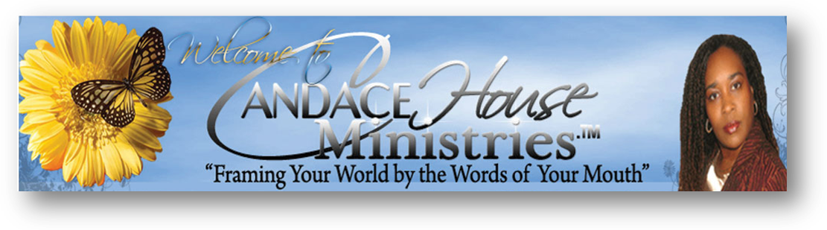
Dr. Candace House’s Biography

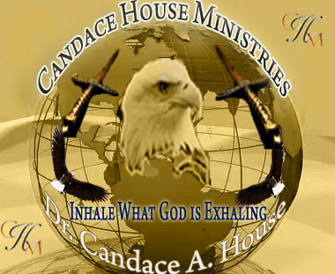
Born Jan 30, 1966, to parents, Dr. Milton and Min. Mattie Mosby, God's Church of Deliverance, Columbia , South Carolina. She & her sister Min Carmen Gray were saved and filled with the Holy Ghost on the same night in 1974.
From that time the Lord began to deal with Candace in a supernatural way. He pulled back the curtains and showed her the Spirit realm. The Gifts of the Spirit began to operate in her life at a very young age. He spoke to her and told her that He had given her the Nations for her inheritance. Prophetic word after prophetic word confirmed her calling. After being disillusioned with Christianity because of Church of issues, Candace left and said she would never return. However eight years later the Lord drew her back into the fold. She surrendered to Him while on the dance floor in a club with a drink in her hand 1995 and has never looked back since.
God has done miraculous things in her life and she is truly a Living testimony to the Grace and Mercy of our God. He brought her back from the dead in 1989 and healed her body from cancer in 1993. He restored her marriage the day before the divorce was final due to infidelity on her part in 1995.
While growing up in South Carolina, she met and married her soul mate, Pastor Anthony House. This marriage brought forth three children, three grandchildren. Candace has traveled extensively due to her husband's affiliation with the U.S. Navy. Their final duty station was Kings Bay Naval Base in Camden County, Georgia. Here is where she finally acknowledged the call to Ministry in Jan of 1996.
Under the covering of her father Dr. Milton Mosby of God’s Church of Deliverance, Columbia S.C. Prophet Candace House is the founder of Ruach Chayah (Breath of Life) Global Ministries and Candace House Ministries, where the anointing to both teach and preach the Word of God in demonstration and power is manifested in her life.
She is ordained as an Evangelist, Teacher, Prophet and Apostle. She holds a Bachelors in Christian Education, Masters in Christian Psychology, a Doctorate of Divinity (D.D.) , Ph.D. in Theology and Christian Psychology as well as a Doctorate in Prophetic Ministry.
Her message to the body of Christ is to “Inhale what God is Exhaling!” for “The Spirit of God has made me and the Breath of the Almighty gives me Life” (Job 33:4). Her mandate is to see the Saints equipped for the work of the ministry, walking in Kingdom authority, and the Manifested Glory of God is revealed personally, regionally and globally in the lives of His people. She is called to impart and activate the gifts in the Body of Christ. Anointed with a true apostolic and prophetic call her desire is to impact the world by restoring, building, perfecting and training to believer to fulfill their destiny.

