Shut The Door Ruach Publishing
It Is Well: Framing Your World One Word at a Time
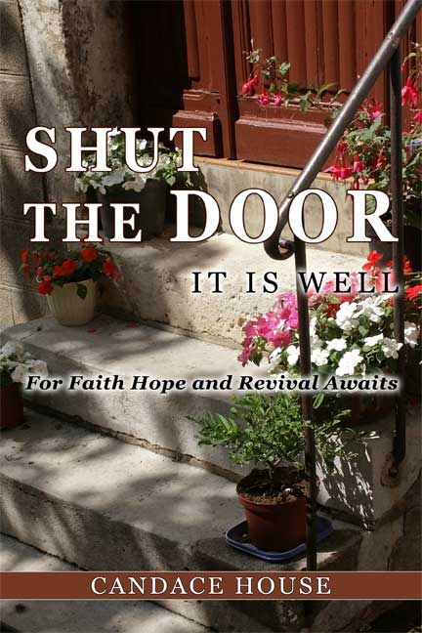
Sept 2007 imprint: Ruach Publishing
Warehouse Date: Sep 6, 2007 In-store Date: Sept 2007

Author: Candace House

Brief Summary:
Shut The Door It Is Well is a book that details how our thinking needs to line up with the Word Of God
in order to live the Abundant Life set forth in Scripture. This book shows us how to be careful of what we speak
into the atmosphere concerning our situations. In order to have the thins that God says are ours we need to
Shut The Door on all negativity in our lives.

title details
133 pages * $12.95 * Paperback * 6 x 9 inches * ISBN: 978-0-6151-5218-9
* Distribution Rights: Worldwide
Categories: Self Help, Devotional

about the book:
We have all been disappointed by life’s circumstances and floored by some tragedy or disappointment. Some have lost love ones. Others have lost their vision. Some have lost hope. Others have lost their will to live. Everyone is looking for relief, a ray of sunshine in the midst of their storm. God said He would never leave us nor forsake us. Yet how many of us have felt abandon by Him at some point in our lives?
Candace points out the problems that may be holding us back from achieving our goal and leads us to Scriptures that we can read and claim to help us to reach the place God wants us to be. By giving examples from the Word we can plainly see that others have made it through with the help of the Lord, His Word, and we can too. Ms. House reminds us of the integrity of God and His Word, bringing to mind that we also as His children must refrain from words that bring death and not life to ourselves and others.

sample Table of Contents:
- Chapter 1: Rest In Him
- Chapter 2: It’s all Good
- Chapter 3: Still Standing
- Chapter 4: He Is His Word
- Chapter 5: Preserve Me Oh God
- Chapter 6: The Hope Of His Calling
- Chapter 7: Make Room For The Supernatural
- Chapter 8: Will We Be Found Faithful
- Chapter 9: The Seed That Cannot Die
- Chapter 10: Living The Abundant Life
- Chapter 11: We Value The Wrong Things
- Chapter 12: Substitutions
- Chapter 13: We Have Another Home
- Chapter 14: Struggling To Breathe
- Chapter 15: Is He Your Desire

about the author:
Candace House is the Founder & CEO The World Education Network Inc (TWEN), a company that provides curriculum, tutoring & technology for students around world. Candace House is also the founder of Ruach Chayah](Breath of Life) Global Ministries. She is an Entrepreneur, Humanitarian, Life Coach, Motivational Speaker and TV and Radio talk show host. She is married with three children and two grandchildren that are her life.
Ruach Publishing * 805 Riverview Dr E* St Marys GA Revised 7/30/2026
Phone (912) 674-6284 * Toll Free (877) 212-8481 * www.ruachchayah.org

