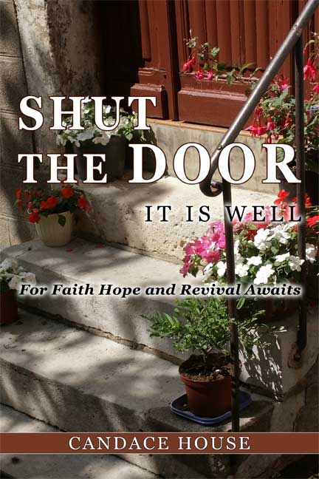Media Contact: Candace House
info@candacehouse.org
October 2006

FOR IMMEDIATE RELEASE

New Release of Shut the Door It Is Well
Gives an In-depth Look into Abundant Living

Oct.- 2006 –Columbia , SC – Candace House, author and CEO of The World Education Network Inc, announces the release of her Motivational book , Shut The Door “It Is Well.” Through mentoring, teaching, speaking events, TV & radio shows, Candace House has had the opportunity to share the truths of what she has learned with others for years. She is excited about the release of her new Motivational book designed to relevantly apply the truth of words and their effect on your circumstances to our everyday lives.
Shut The door It Is well, published by Ruach Publishing is a book designed to
teach you how to arm yourself against defeat. This guide will show you how to be victorious in every aspect of your life. If you have been waiting to live an Abundant life Shut the Door It Is Well will give you tools necessary to bring your life in alignment with the Word. Through these principles you will gain understanding of how you can take control of your circumstances and turn them into blessings. This book will help people in every walk of life reach a deeper understanding of the words we speak and the power they have.
SHUT THE DOOR IT IS WELL will be released for purchase on the internet and in local bookstores in Sept 2007, and it is currently available for pre-sale at those locations.
Not only is it a book of teaching but it is a book of encouragement, revelation and definitely points to a God who loves us and is interested in our well-being.It is said, "how can we learn if we are never fed?" and "how can we heal if we have no balm?" Within the pages of this work you truly will be feed His Word and receive His healing balm upon your Spirit. A book from the heart of God to the heart of mankind.

Shirley Johnson
Senior Reviewer
MidWest Book Review

More information about Candace House, The World Education Network Inc, and Shut The Door It Is Well is available at www.candacehouse.org. Candace’s other published works include: What Is God Eating? (Lulu, 2007), and contributing author for several online magazines. Candace is available for book signing events, speaking reservations, and media interviews, and can be contacted at info@candacehouse.org or by phone at 912-674-6284.

Shut The Door It Is Well
ISBN: 978-0-6151-5218-9
Ruach Publishing

